# Department of Software Engineering

**CS-114: Fundamentals of Programming**

**Class:** BE(SE)-11B

**NAME : AFRAZ AHMED**

**CMS ID: 349181**

Lab 03: Input, Output, Expressions, and Data types

**Date:** November3, 2020

**Time:** 10:00 am -12:50 pm

**Instructor:** Dr. Arham Muslim

**Lab Engineer:** Ms. Sara Mehmood

**Lab 02: Introduction to Python programming and familiarity with IDLE**

**Introduction**

This lab is designed to develop the understanding of students with python input and arithmetic operations.

**Objectives**

In this lab the students will learn and practice to attain the user input from keyboard and will perform basic arithmetic operations on the obtained numbers.

**Tools/Software Requirement**

Python IDLE

**Description**

Follow the lab manual step by step. As you proceed, you will be asked to add screenshots/snaps of your results inside the provided output windows within this manual for grading purposes.

**Output using print function**

#### The print function is used to display the message to the console.

|  |
| --- |
| >>> print(1 + 1) 2  >>> print("The Latin 'Oryctolagus cuniculus' means 'domestic rabbit'.")  The Latin 'Oryctolagus cuniculus' means 'domestic rabbit'. |

**Obtaining User Input**

Another built-in function that you will find useful is the input function. The input() function reads a line entered on a console by an input device such as a keyboard and converts it into a string and returns it. You can save the input string into a variable to use this input string further in your python code:

|  |
| --- |
| >>> species = input("Enter a value: ")Homo sapiens>>> species 'Homo sapiens' |

See the snapshot below for a clear understanding on the usage of input() function:

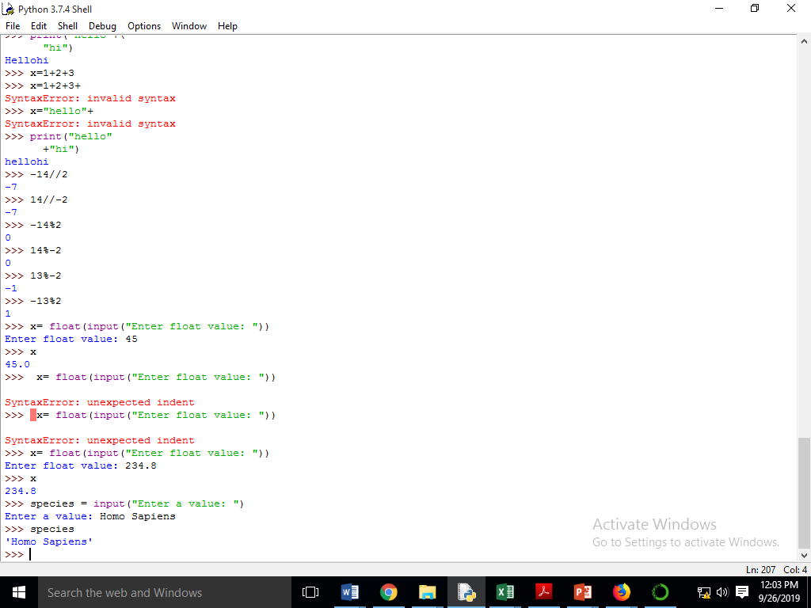

In Python, every input result is string type. Whatever you enter as an input, the input() function always converts it into a string. If you enter an integer value, still input() function converts it into a string. However, we can convert it into other types i.e. int, float etc. as follows:

#### >>> x= **int**(input(“Enter integer value: ”)) 57

#### >>> x

#### 57

There are no quotation marks with the output value above which indicates that it is **int** type.

Similarly, if your program requires the user to enter a **float** number you can use the following syntax:

#### >>> x= **float**(input(“Enter float value: ”))

#### 57.8

#### >>> x

#### 57.8

**Arithmetic Operators**

The Python interpreter can be used to express the arithmetic operators in a very simple way as described below:

|  |
| --- |
| **# For Addition**  >>> 1 + 1  2 |
| **# For Multiplication**  >>> 2 * 3  6 |
| **# For Integer Division**  >>> 17//10 1 >>> -17//10 -2 |
| **#For Modulus**  >>> 27%10 7 >>> -27%10 3 |

**Lab Tasks:**

1. For each of the following expressions, what value will the expression give? Verify your answers by typing the expressions into Python. State your answers in the answer box provided below:
   1. 9 - 3
   2. 8 * 2.5
   3. 9 / 2
   4. 9 / -2
   5. 9 // -2
   6. 9 % 2
   7. 9.0 % 2
   8. 9 % 2.0
   9. 9 % -2
   10. -9 % 2
   11. 9 / -2.0
   12. 4 + 3 * 5
   13. (4 + 3) * 5

**Answers:**

|  |  |  |
| --- | --- | --- |
| **Expression** | **Estimation** | **Python Result** |
| **9-3(SUBTRACTION)** | **6** | **6** |
| **8 * 2.5(MULTIPLICATION)** | **20** | **20.0** |
| **9/2(DIVISION)** | **4.5** | **4.5** |
| **9/-2(DIVISION)** | **-4.5** | **-4.5** |
| **9//-2(INTEGRAL DIVISION)** | **-4** | **-5** |
| **9%2(MODULUS)** | **1** | **1** |
| **9.0%2(MODULUS)** | **1** | **1.0** |
| **9%2.0(MODULUS)** | **1** | **1.0** |
| **9%-2(MODULUS)** | **-1** | **-1** |
| **-9%2(MODULUS)** | **-1** | **1** |
| **9/-2.0(MODULUS)** | **-4.5** | **-4.5** |
| **4+3*5(ADDITION + MULTIPLICATION)** | **19** | **19** |
| **(4+3)*5(ADDITION + MULTIPLICATION)** | **35** | **35** |

1. Which of the following expressions result in Syntax Errors? Identify the Syntax Errors and type the reason of error along with the correct code by mentioning its sequence number.
   1. 6 * -----------8
   2. 8 = people
   3. ((((4 ** 3))))
   4. (-(-(-(-5))))
   5. 4 += 7 / 2

|  |  |  |
| --- | --- | --- |
| **Expression** | **Type of Error** | **Correct Statement** |
| 6 * -----------8 | Extra unnecessary use of (-) sign | 6*-8 |
| 8 = people | SYNTAX ERROR: A number cannot be variable. | people = 8 |
| ((((4 ** 3)))) | Extra unnecessary use of () sign | (4**3) |
| (-(-(-(-5)))) | Extra unnecessary use of (-) sign | -(-5) |
| 4 += 7 / 2 | SYNTAX ERROR : We should first assign any variable to number ‘4’ and then executethe program. | x = 4  x += 7/2 |

**Answers:**

1. Given variables x and y, which refer to values 3 and 12.5, respectively, use function print( ) to print the following messages. When numbers appear in the messages, variables x and y should be used.
   1. The rabbit is 3.
   2. The rabbit is 3 years old.
   3. 12.5 is average.
   4. 12.5 * 3
   5. 12.5 * 3 is 37.5.

**Solution:**

x = 3  
  
y = 12.5  
print("The rabbit is" , x)  
print("The rabbit is" , x , "years old")  
print(y , "is average")

print(y ," * 3")

print(y ," * 3 is 37.5")

"C:\Users\Moavia computer\PycharmProjects\pythonProject\venv\Scripts\python.exe" "C:/Users/Moavia computer/PycharmProjects/pythonProject/main.py"

The rabbit is 3

The rabbit is 3 years old

12.5 is average

12.5 * 3

12.5 *3 is 37.5

1. Write a program that prompts the user to input two values. Assign user defined values to two variables and then swap their values. Print the swapped values to verify the results of your program.

**Solution:**

x = input("Enter number 1 :")  
y = input("Enter number 2 : ")  
print('SWAP THEIR VALUES')  
print("Enter number 1 : " , y )  
print("Enter number 2 :" , x)

"C:\Users\Moavia computer\PycharmProjects\pythonProject\venv\Scripts\python.exe" "C:/Users/Moavia computer/PycharmProjects/pythonProject/main.py"

Enter number 1 : 99

Enter number 2 : 76

SWAP THEIR VALUES

Enter number 1 : 76

Enter number 2 : 99

1. Using only the techniques you have learned so far, write a program that calculates the square and cube of the numbers from 0 to 10 and uses tabs (use \t in the print statement to add tab) to print the following table of values:

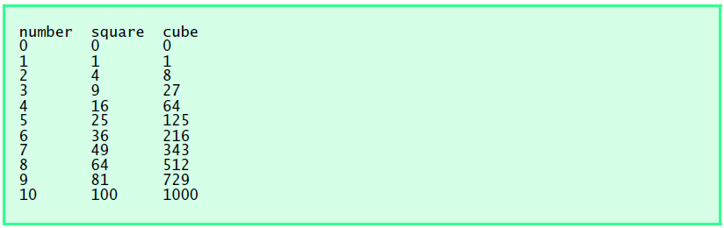

**Solution:**

a=0  
b=1  
c=2  
d=3  
e=4  
f=5  
g=6  
h=7  
i=8  
j=9  
k=10  
print("Number","\t\t","Square","\t\t" , "Cube")  
print(a,"\t\t\t",a*a,"\t\t\t",a*a*a)  
print(b,"\t\t\t",b*b,"\t\t\t",b*b*b)  
print(c,"\t\t\t",c*c,"\t\t\t",c*c*c)  
print(d,"\t\t\t",d*d,"\t\t\t",d*d*d)  
print(e,"\t\t\t",e*e,"\t\t\t",e*e*e)  
print(f,"\t\t\t",f*f,"\t\t\t",f*f*f)  
print(g,"\t\t\t",g*g,"\t\t\t",g*g*g)  
print(h,"\t\t\t",h*h,"\t\t\t",h*h*h)  
print(i,"\t\t\t",i*i,"\t\t\t",i*i*i)  
print(j,"\t\t\t",j*j,"\t\t\t",j*j*j)  
print(k,"\t\t\t",k*k,"\t\t\t",k*k*k)

Insert screen shot for output here"C:\Users\Moavia computer\PycharmProjects\pythonProject\venv\Scripts\python.exe" "C:/Users/Moavia computer/PycharmProjects/pythonProject/main.py"

Number Square Cube

0 0 0

1 1 1

2 4 8

3 9 27

4 16 64

5 25 125

6 36 216

7 49 343

8 64 512

9 81 729

10 100 1000

1. Write a program that asks the user to enter two numbers, obtains the two numbers from the user and prints the sum, product, difference, quotient and remainder of the two numbers. Sample output is as follows:

Enter number 1 : 20

Enter number 2 : 5

The sum is : 25

The product is : 100

The difference is : 15

The quotient is : 4

The modulus is : 0

**Solution:**

x = int(input('Enter number 1 : '))  
y = int(input('Enter number 2 : '))  
c = x + y  
a = x*y  
b = x-y  
d = x//y  
h = x%y  
print("The sum is :" , c)  
print("The product is :" , a)  
print("The difference is :" , b)  
print("The quotient is :" , d)  
print("The modulus is :" , h)

"C:\Users\Moavia computer\PycharmProjects\pythonProject\venv\Scripts\python.exe" "C:/Users/Moavia computer/PycharmProjects/pythonProject/main.py"

Enter number 1 : 20

Enter number 2 : 5

The sum is : 25

The product is : 100

The difference is : 15

The quotient is : 4

The modulus is : 0

1. Write a program that reads in the radius of a circle and prints the circle’s diameter, circumference and area. Use the constant value 3.14159 for π(pi). Perform each of these calculations inside the print statement(s).

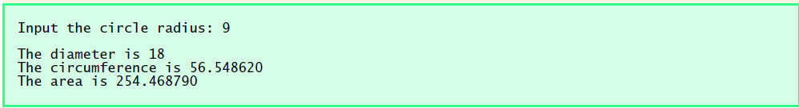

**Solution:**

x = int(input("INPUT The Cirle Radiius : " ))  
print("The diameter is : " , 2*x)  
print("The cirumference is : " , 2*3.14*x)  
print("The area is : " , 3.14*x*x )

Insert screen shot for output here "C:\Users\Moavia computer\PycharmProjects\pythonProject\venv\Scripts\python.exe" "C:/Users/Moavia computer/PycharmProjects/pythonProject/main.py"

INPUT The Cirle Radiius : 9

The diameter is : 18

The cirumference is : 56.52

The area is : 254.34

1. Write a program that prints the absolute value of the number entered by a user

**CODE :-**

x = int(input("Please input a number : "))  
print(abs(x))

**OUTPUT:-**

**"C:\Users\Moavia computer\PycharmProjects\pythonProject\venv\Scripts\python.exe" "C:/Users/Moavia computer/PycharmProjects/pythonProject/main.py"**

**Please input a number : -13**

**13**

1. Write a program that reads in the year entered by a user and displays if the year entered is a leap year or not. A year divisible by 4 is a leap year but if it is divisible by 100 then it is not a leap year unless it is divisible by 400 in which case it is a leap year

**CODE:-**

x=int(input("Please enter a year : "))  
if x%4==0:print("the year is a leap year")  
elif x%100==0:print("the year is not a leap year")  
elif x%400==0:print("the year is leap year :")  
else : print("the year is not a leap year")

**OUTPUT:-**

**"C:\Users\Moavia computer\PycharmProjects\pythonProject\venv\Scripts\python.exe" "C:/Users/Moavia computer/PycharmProjects/pythonProject/main.py"**

**Please enter a year : 2000**

**the year is a leap year**

10. A school has following rules for grading system:

a. Below 25 - F

b. 25 to 45 – E

c. 45 to 50 - D

d. 50 to 60 - C

e. 60 to 80 - B

f. Above 80 - A

Ask user to enter marks and print the corresponding grade.

**CODE:-**

x=int(input('Enter your marks : '))  
if x>=80:print('You have obtained grade A')  
elif x>=60:print('You have obtained grade B')  
elif x>=50:print('You have obtaned grade C')  
elif x>=45:print('You have obtained grade D')  
elif x>=25:print('You have obtained grade E')  
else:print('You have obtained grade F')

**OUTPUT:-**

**"C:\Users\Moavia computer\PycharmProjects\pythonProject\venv\Scripts\python.exe" "C:/Users/Moavia computer/PycharmProjects/pythonProject/main.py"**

**Enter your marks : 23**

**You have obtained grade F**